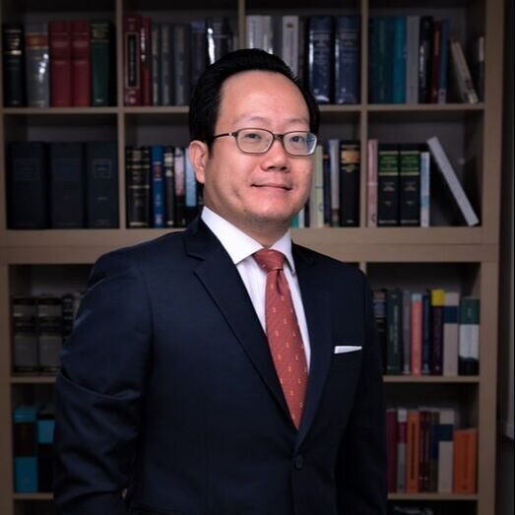
Stephen Cheong
Advocate & Solicitor
Sharpe & Jagger LLC
24 Raffles Place
29-03 Clifford Centre
Singapore 048621

Email: stephen.cheong@sjlaw.com.sg

Telephone: (65) 6694 7281

Biography

My practice covers international arbitration and litigation with a particular focus on insurance and reinsurance disputes as well as cross-border disputes management and resolution in the Asia Pacific and South East Asian region.

On the insurance front, I represent insurers and policyholders in the full spectrum of non-marine insurance and reinsurance-related matters. I specialize in large scale property, energy and construction losses and advise clients on contentious and non-contentious policy-related issues that include policy interpretation, coverage and quantum and provides representation in settlement negotiations, mediations, arbitrations and litigation.

I have established a strong network with leading local law firms in the Asia Pacific and South East Asian region and am regularly instructed by local counsel to advise and represent clients in international arbitration proceedings arising out of shareholder, joint venture, manufacturing and distribution and construction and engineering related disputes and am fluent in the institutional rules of major arbitral institutions including SIAC, HKIAC, ICC, ACICA, LCIA and UNCITRAL.

In addition, I also represent clients in a wide range of commercial litigation disputes before the Singapore Courts.

Recognition

- Recommended, Dispute Resolution: Local Firms, The Legal 500 (2019).

Representative Matters

Insurance and Reinsurance

- Assisting international insurers and reinsurers in respect of contentious and non-contentious matters arising out of and in connection with the catastrophic Thailand Floods of October 2011. The total quantum in dispute was in excess of THB 100 billion.

- Working closely with insurers and local counsel to defend worldwide business interruption claims commenced by a US car manufacturing conglomerate for worldwide business interruption losses arising out of the 2011 Thailand Floods. Approximately US$69 million was at stake.

- Representing national independent power producer in ad hoc arbitration proceedings against insurers for property damage and business interruption losses arising from turbine failure of a coal-fired power plant in Malaysia. Approximately US$70 million was at stake.

- Acting for a Philippine reinsurer in a dispute against a US retrocessionaire arising out of and in connection with an excess of loss treaty covering losses subsequent to the Thailand Floods of October 2011. Approximately PHP 250 million was at stake.

- Acting for and advising an international reinsurance syndicate against a property damage and business interruption claim arising from turbine failure in the Philippines. Approximately US$65 million was at stake.

- Acting for and advising an international independent power producer in a machinery breakdown and business interruption claim against Insurers for losses arising from failure of a power plant in Sri Lanka.

- Acting for and advising the subsidiary of a conglomerate listed on the Stock Exchange of Thailand in a material damage and business interruption claim against Insurers for losses arising from Fire damage to a crude oil refinery. Approximately US$45 million was at stake.

- Representing a policyholder in a claim against an insurer for wrongful repudiation and cancellation of a jewellery block policy.

- Representing insurers of a property management company in the successful resolution of a multi-million dispute instituted by the property under management arising out of and in connection with the defalcation by a former employee of the insured.

- Advising a Singaporean conglomerate on matters relating to policy coverage following a comprehensive review of existing Director & Officer Liability Policies.

International Arbitration

- Representing a listed mining and processing company in ACICA arbitration proceedings against a global engineering company for damages and loss of profits arising out of the catastrophic failure of mining equipment. Approximately US$85 million was at stake.

- Representing the subsidiary of a conglomerate listed on the Stock Exchange of Thailand in SIAC arbitration proceedings (including emergency arbitration proceedings for urgent interim relief) arising out of a joint venture mining dispute. Approximately S$4.2 million was at stake.

- Representing a Taiwanese manufacturer of scooters and quadbikes in SIAC arbitration proceedings against a French importer and distributor following the termination of the commercial relationship. More than EUR 12 million was at stake.

- Representing a Thailand-based company engaged in agro-industrial business and production of food in expedited SIAC arbitration proceedings in Singapore arising out of a share purchase agreement dispute. More than THB 91 million was at stake.

- Representing a Thailand-based company engaged in the entertainment industry in JAMS arbitration proceedings seated in Los Angeles, California, USA, arising out of a licensing agreement dispute. More than USD 5 million was at stake.

Court Litigation and Mediation

- Obtaining summary judgment against an individual in respect of breach of the terms of a share purchase agreement.

- Appointed by professional and indemnity liability insurers (P&I) to defend an architect in Singapore High Court proceedings commenced by the owners of a hotel for loss of profits occasioned by the delay in completion of the construction works due to alleged professional negligence.

- Advising and representing the former CEO of a mining company in a multi-million dollar dispute arising from the wrongful retention of termination benefits by his former employer.

- Representing the operator of a commercial mall in mediation proceedings to resolve disputes arising between the operator, tenants, contractors and various stakeholders.

Speaking Engagements

- Joint speaker at a seminar entitled “IPO Listings – Managing Risk; Unlocking Potential”, organized jointly by Markel International Singapore and SGX in 2014 on topics covering the transfer of risk in M&A financial lines.

- Speaker at the 2014 Construction Law Conference organized by the Society of Construction Law on “Transferring Risk – Current Challenges Facing the Construction Industry and Mitigating Risks in Projects – A Legal Perspective”.

- Conducted inhouse seminars to clients on “Fundamentals of Contract Law” and “Legal Proceedings and Alternative Dispute Resolution in Singapore”.

- Participated in Morgan Lewis inhouse seminars to clients on “How Third Party Funding for Dispute Resolution is Impacting the Insurance Industry in Asia”.

- Participated in Morgan Lewis inhouse seminars to clients: “First Thailand Now Texas: Wide Area Flood Damage and the Critical Coverage Issues”.

- Expert Witness Institute Conference Singapore 2019 Panelist “Expert Evidence in the Asia Pacific Region. Expert Evidence in International Arbitration”.

Professional Memberships

- Member of the Singapore Institute of Legal Education.
- Member of the Law Society of Singapore.
- Fellow of the Singapore Institute of Arbitrators
- Fellow of the Asian Institute of Alternative Dispute Resolution.
- Senior Fellow of the Bali International Arbitration and Mediation Centre.
- Member of the Chartered Institute of Arbitrators
- Panel of Arbitrators, Thailand Arbitration Centre (THAC)

Admissions

- Advocate and Solicitor, Singapore.

Academic Record

- National University of Singapore, LLB Hons.

